OCPW/ALS/DA-11-002
District Attorney
801 Civic Center Drive West, Suite 400
Santa Ana, CA 92701

LEASE

THIS IS A LEASE (hereinafter referred to as “Lease”) made , 2011, by and between Birtcher Anderson Investors, LLC, a Delaware limited liability company (hereinafter referred to as “LESSOR”) and the COUNTY OF ORANGE, a political subdivision of the State of California (hereinafter referred to as “COUNTY”) without regard to number and gender. The term “COUNTY” shall mean the Board of Supervisors of the political body that executed this agreement or its authorized representative.

- DEFINITIONS (1.2 S)

“Board of Supervisors” means the Board of Supervisors of the County of Orange, a political subdivision of the State of California.

“Corporate Real Estate” means OC Public Works, OC Facilities and Real Estate, Corporate Real Estate, County of Orange, or upon written notice to LESSOR, such other entity as shall be designated by the Director of OC Public Works.

“County Counsel” means the County Counsel, County of Orange, or designee, or upon written notice to LESSOR, such other person or entity as shall be designated by the County Executive Officer or the Board of Supervisors.

“County Executive Officer” means the County Executive Officer, County Executive Office, County of Orange, or designee, or upon written notice to LESSOR, such other person or entity as shall be designated by the Board of Supervisors.

“Director of OC Public Works” means the Director, OC Public Works, County of Orange, or designee, or upon written notice to LESSOR, such other person or entity as shall be designated by the County Executive Officer.

“District Attorney” means the District Attorney, County of Orange, or designee, or upon written notice to LESSOR, such other person or entity as shall be designated by the County Executive Officer or the Board of Supervisors.

“Manager of Corporate Real Estate” means the Manager, OC Public Works, OC Facilities and Real Estate, Corporate Real Estate, County of Orange, or designee or upon written notice to LESSOR, such other person or entity as shall be designated by the Director of OC Public Works.
//

//

//

//
- PREMISES (1.3 S)

LESSOR leases to COUNTY that certain property hereinafter referred to as “Premises,” described in Exhibit “A” and shown on Exhibit “B,” which exhibits are attached hereto and by reference made a part hereof, together with non-exclusive, in common use of LESSOR’s elevators, stairways, washrooms, hallways, driveways for vehicle ingress and egress, pedestrian walkways, other facilities and common areas appurtenant to COUNTY’s Premises created by this Lease.

- PARKING (1.4 N)

LESSOR, throughout the term of this Lease, shall provide a total of one hundred seventy-two (172) forty-four (44) parking spaces consisting of ten (10) parking spaces designated for COUNTY’s free and exclusive use, and one hundred sixty-two (162) thirty-four (34) parking spaces for COUNTY’s free and non-exclusive use. Said parking spaces are to be located in the parking area shown on Exhibit “B.”

COUNTY, throughout the term of this Lease, shall have the right to increase (subject to availability) or decrease the quantity of parking spaces provided at the rate of forty dollars ($40) per space. Prior to any adjustment in the number of parking spaces, COUNTY and LESSOR shall agree in writing as to the number of parking spaces to be adjusted. Should COUNTY exercise its right to increase or decrease the quantity of parking spaces pursuant to this clause the additional charge or reduction shall be prorated in accordance with the change in the number of parking spaces occupied during any one month and shall be billed as Additional Rent pursuant to Clause 5 (RENT). COUNTY shall pay the reasonable cost of parking cards and any replacement cards for any additional parking spaces.

In addition to said parking spaces, LESSOR shall also provide parking for disabled persons in accordance with the Americans with Disabilities Act, Section 7102 of the California Uniform Building Code and the applicable codes and/or ordinances relating to parking for disabled persons as established by the local jurisdiction in which the Premises is located where the provisions of such local codes and/or ordinances exceed or supersede the State requirements.

- TERM (2.2 S)

The term of this Lease for the Original Premises commenced on October 1, 2012 (the “Original Premises Commencement Date”), and will expire on the date that is ten (10) years after the Expansion Premises Commencement Date. The term of this Lease for the Expansion Premises will commence on the Expansion Premises Commencement Date and will expire on the date that is ten (10) years after the Expansion Premises Commencement Date. As used herein, the “Expansion Premises Commencement Date” shall mean shall be ten (10) years, commencing the first day of the first full calendar month following the date of execution by COUNTY, or commencing the first day of the first full calendar month following the completion by LESSOR of the work set out in Clause 10 (CONSTRUCTION) whichever date is later (“Commencement Date”).

Parties agree that the Commencement Date the term of this Lease (including the Expansion Premises Commencement Date) of this Lease will be confirmed in writing by either party upon demand by the other.

- OPTION TO EXTEND TERM (2.3 S)

COUNTY shall have the option to extend the term of this Lease for two (2) five (5) year periods on the same terms and conditions except for rent which shall be negotiated at the time of the option and memorialized in an amendment to the Lease. Any extension of the term of this Lease under this Clause 5 shall extend the term of this Lease for both the Original Premises and the Expansion Premises. Notification of said exercise of option shall be done in writing, not more than nine (9) months and no less than six (6) months at least sixty (60) days prior to the Lease termination date. Notwithstanding the foregoing, COUNTY may not extend the term of this Lease if, at either the time of notification or at the end of the initial Lease termination date, COUNTY is in default under this Lease or COUNTY is in breach of this Lease and LESSOR has delivered a written notice regarding such breach to COUNTY pursuant to Clause 31 (NOTICES) of this Lease.

//

//
- OPTION TO TERMINATE LEASE (2.4A N)

COUNTY shall have the option to terminate this Lease at any time after three (3) years after the Expansion Premises Commencement Date the third (3rd) year of the Lease term upon giving LESSOR written notice at least one hundred eighty (180) days prior to said termination date. Notwithstanding the foregoing, COUNTY may not terminate the term of this Lease if, at either the time of notification or at the termination date, COUNTY is in default under this Lease, or COUNTY is in breach of this Lease and LESSOR has delivered a written notice regarding such breach to COUNTY pursuant to Clause 31 (NOTICES) of this Lease.

Should COUNTY exercise said option, LESSOR may, within thirty (30) days after the Lease termination date, make a claim for reimbursement of the unamortized cost of COUNTY-required improvements only. The amount of said reimbursement shall be determined as follows:

Reimbursement Amount | = | $2,590 | x | (120 months less the number of months of the lease term elapsed from the Commencement Date)

*This First Reimbursement Amount shall be fully amortized on September 30, 2022.

Plus

Second Reimbursement Amount | = | $6,119 | x | (120 months less the number of months of the lease term elapsed from the Expansion Premises Commencement Date)

If no claim is received by COUNTY within the thirty (30) day period after Lease termination, LESSOR’s right to reimbursement shall be deemed waived. COUNTY shall have sixty (60) days after receipt of the claim by LESSOR to pay said claim.

- COUNTY’S RIGHT TO LEASE ADDITIONAL SPACE (2.5 S)

Should additional space become available within LESSOR’s building or property, either as a result of the termination of occupancy of another building tenant, or construction by LESSOR of additional space onto LESSOR’s building, COUNTY shall have the right of first refusal to lease such additional space. COUNTY’s right of first refusal shall extend for a period of ninety (90) days following COUNTY’s receipt of LESSOR’s written notice of the availability of said space. COUNTY’s occupancy of said space shall be subject to the terms and conditions of this Lease and rental for said space shall be based upon the rental rate which COUNTY is paying for the Premises at the time COUNTY’s occupancy of the additional space commences.

- RENT (3.2 S)

COUNTY agrees to pay to LESSOR as rent for the Premises the sum of seventeen thousand three hundred eighty-two dollars ($17,382) per month for the Original Premises and Fifty-Two Thousand Seven Hundred Fifty-Five Dollars ($52,755) for the Expansion Premises for a total of Seventy Thousand One Hundred Thirty-Seven Dollars ($70,137). Notwithstanding the foregoing, the first (1st),and thirteenth (13th) and twenty-fifth (25th) months of the Lease term (counting from the Expansion Premises Commencement Date) shall be rent free.

To obtain rent payments LESSOR (or LESSOR’s designee) shall submit to COUNTY’s District Attorney, in a form acceptable to said District Attorney, a written claim for said rent payments.

Payment shall be due and payable within twenty (20) days after the later of the following:

  - The first day of the month following the month earned; or

  - Receipt of LESSOR’s written claim by the District Attorney.

Should COUNTY occupy the Expansion Premises before the Expansion Premises Commencement Date first day of the Lease term, LESSOR shall be entitled to pro rata rent for the period of occupancy and the amount of space occupied in the Expansion Premises prior to Expansion Premises Commencement Date the beginning of the Lease term based upon the monthly installment the monthly installment for the Expansion Premises for the second (2nd) month as set forth above. Said rent shall be included in the rent claim submitted by LESSOR for the first full month of the Lease term and shall be paid by COUNTY at the time of payment for said month.

COUNTY shall pay any Additional Rent in accordance with this clause. Additional Rent consists of charges for additional parking spaces pursuant to Clause 3 (PARKING), after move-in tenant improvements pursuant to Clause 14 (COUNTY-REQUESTED ALTERATIONS), and/or after-hour air conditioning charges pursuant to Clause 17 (UTILITIES).

- RENT ADJUSTMENT (3.3 S)

The monthly rental payable by COUNTY for the Premises shall be automatically adjusted as follows:

Months | Monthly Rental
37-48 | $17,708
49-60 | $18,034
61-72 | $18,468
73-84 | $18,795
85-96 | $19,229
97-108 | $19,772
109-120 | $20,098

Months after Expansion Premises Commencement Date | Original Premises  Monthly Rent | Expansion Premises  Monthly Rent | Total Monthly Rent
13 | $17,708 | Rent-Free | $17,708
14-24 | $17,708 | $52,755 | $70,463
25-36 | $18,034 | $52,755 | $70,789
37-48 | $18,468 | $54,034 | $72,502
49-60 | $18,795 | $54,034 | $72,829
61-72 | $19,229 | $55,313 | $74,542
73-84 | $19,772 | $55,313 | $75,085
85-96 | $20,098 | $56,912 | $77,010
97-108 | $19,338 | $56,912 | $76,250
109-120 | $19,772 | $58,191 | $77,963”

- CONSTRUCTION (4.1 S)

LESSOR hereby agrees to complete, at LESSOR’s expense, within 120 calendar days after the date first written above (“Completion Period”), alterations, repairs, and other work (the ”Work”) in accordance with the plans dated May 19, 2011 and May 25, 2011 and Specifications and Working Drawings dated May 9, 2014, attached hereto and made a part hereof as Exhibit “C Revised Exhibit C (the “Plans and Specifications”).”

Should LESSOR fail to complete the Work within the Completion Period other than for reasons of Tenant Delay or pursuant to General Condition Clause 7 (CIRCUMSTANCES WHICH EXCUSE PERFORMANCE) attached hereto 120 calendar days after execution of the Lease by COUNTY, COUNTY shall reduce subsequent rent due LESSOR by $500.00 $1,759 for each day the completion date of the Work exceeds the above mentioned 120-day period. Said amount shall be considered as liquidated damages to compensate COUNTY for costs incurred as a result of such LESSOR-caused delay. In addition to the amount stated above, COUNTY may, at COUNTY’s sole option, upon giving written notice to LESSOR prior to the completion of the Work, terminate the Lease if LESSOR has not completed the Work within one hundred and eighty (180) days after the date first written above other than for reasons of Tenant Delay or pursuant to General Condition Clause 7 (CIRCUMSTANCES WHICH EXCUSE PERFORMANCE) attached hereto. In the event of such termination, this Lease shall terminate on the date specified in such notice and neither party shall have any further right or obligation to the other with respect to this Lease or the Premises.

All planning and architectural/design costs required to accomplish the Work shall be LESSOR’s responsibility. COUNTY acknowledges and agrees that the Plans and Specifications for the attached space plan have already been approved by All plans and working drawings for the Work shall have the approval of the District Attorney. All construction plans and working drawings for the Work (the “CPWD”) shall have the approval of the District Attorney. The District Attorney shall either approve or not approve the CPWD within twenty (20) days of its receipt of the CPWD or the CPWD shall be deemed approved. If the District Attorney does not approve the CPWD, the District Attorney shall provide a list of reasonable complaints as to why the CPWD were not approved. Upon any resubmission of the CPWD for the District Attorney to review the CPWD to confirm that such complaints have been remedied, the District Attorney shall have fifteen (15) business days to so confirm, and if the District Attorney does not respond within such fifteen (15) business day period, the CPWD shall be deemed to be approved. Approval by District Attorney of said plans and work drawings shall not relieve LESSOR of the responsibility for complying with all applicable codes and construction requirements, nor of obtaining necessary permits or approvals from the authorities of proper jurisdiction.

Subsequent to the completion of the Work, and prior to occupancy by COUNTY, LESSOR shall obtain the District Attorney’s approval and acceptance of the Work. The District Attorney will inspect the Work within fifteen (15) days of a written request by LESSOR. Said approval shall be manifested by letter from the District Attorney within twenty (20) days of inspection, and may be subject to completion of items on a “punch list”. Said punch list will be generated by COUNTY. COUNTY shall have the option not to accept the Premises prior to completion of all items on any such punch list. If the District Attorney does not respond within twenty (20) days after inspection the Work shall be deemed approved. If the District Attorney does not approve the Work, the District Attorney shall provide a list of reasonable complaints as to why the Work was not approved. Upon any resubmission of the Work for the District Attorney to review the Work to confirm that such complaints have been remedied, the District Attorney shall have fifteen (15) business days to so confirm, and if the District Attorney does not respond within such fifteen (15) business day period, the Work shall be deemed to be approved.

In the event COUNTY’s approval and acceptance of the Premises is given prior to the completion of a punch list, LESSOR shall have twenty-one (21) working days following receipt of said punch list to complete all remaining work contained therein. Should the items on the punch list not be completed within twenty-one (21) working days, COUNTY shall have the option to complete the Work and deduct the cost thereof, including labor, materials, and overhead from any rent payable.

- PAINTING BY LESSOR (4.2 S)

Within sixty (60) days prior to the Commencement Date of this Lease and within sixty days (60) days of the commencement of the sixth (6th) and eleventh (11th) year of the Lease term, (should COUNTY exercise its option to extend the Lease term), LESSOR shall repaint, at LESSOR’s sole expense, all painted surfaces within the Premises. Said painting shall be accomplished during hours other than COUNTY’s normal working hours. LESSOR shall be responsible for the movement and subsequent replacement of all furniture, window coverings, and fixtures necessary to repaint the Premises. Said paint shall meet the specifications provided in the attached Exhibit C of this Lease or acceptable equivalent approved by the District Attorney.

At COUNTY’s sole option, COUNTY may elect to defer said repainting. Said deferral shall not release LESSOR from the obligation to repaint. Should COUNTY elect to defer said repainting, the District Attorney shall notify LESSOR in writing of COUNTY’s decision to defer said repainting at least thirty (30) days prior to the scheduled repainting date. This notice shall include the date that the COUNTY wishes the repainting to take place.

Should LESSOR fail to comply with the provisions of this clause, COUNTY shall have the option to complete said repainting and deduct the cost thereof, including overhead, from any rent payable.

- CARPETING BY LESSOR (4.3 N)

Within sixty (60) days prior to the commencement of the eleventh (11th) year of the Lease term, (should COUNTY exercise its option to extend the Lease term), LESSOR shall recarpet, at LESSOR’s sole expense, all carpeted surfaces within the Premises. Said recarpeting shall be accomplished during hours other than COUNTY’s normal working hours. LESSOR shall be responsible for the movement and subsequent replacement of all furniture and fixtures necessary to recarpet the Premises. COUNTY shall, at its own cost and expense, be responsible for the movement and subsequent replacement of all computer equipment, electronic equipment, any other communication equipment, and all otherwise sensitive equipment identified by the District Attorney. Said carpet shall meet the specifications provided in the attached Exhibit C of this Lease or acceptable equivalent approved by the District Attorney.

At COUNTY’s sole option, COUNTY may elect to defer said recarpeting. Said deferral shall not release LESSOR from the obligation to recarpet. Should COUNTY elect to defer said recarpeting, the District Attorney, shall notify LESSOR in writing of COUNTY’s decision to defer said recarpeting at least thirty (30) days prior to the scheduled recarpeting date. This notice shall include the date that the COUNTY wishes the recarpeting to take place.

Should LESSOR fail to comply with the provisions of this clause, COUNTY shall have the option to complete said recarpeting and deduct the cost thereof including overhead, from any rent payable.

- ALTERATIONS (4.4 S)

COUNTY may make improvements and changes in the Premises (collectively “Alteration” or “Alterations”), including but not limited to the installation of fixtures, partitions, counters, shelving, and equipment as deemed necessary or appropriate by the COUNTY in its discretion. It is agreed that any such fixtures, partitions, counters, shelving, or equipment attached to or placed upon the Premises by COUNTY shall be considered as personal property of COUNTY, who shall have the right to remove same. COUNTY agrees that the Premises shall be left in as good condition as when received, reasonable wear and tear excepted. Notwithstanding the foregoing, COUNTY shall be required to obtain the prior written consent of LESSOR for any Alterations, which consent shall not be unreasonably withheld, except for Alterations which are: (1) of a cosmetic nature such as painting, wallpapering, hanging pictures and installing carpeting; (2) not visible from the exterior of the Premises or Building; (3) of a nature that will not affect the systems or structure of the Building; (4) of a nature that will not require work to be performed inside the walls or above the ceiling of the Premises; and (5) of a nature that the cost of which will not be in excess of $75,000.00 per Alteration. As a condition for LESSOR to consent to any Alterations, LESSOR may require COUNTY to provide plans and specifications reasonably acceptable to LESSOR; names of contractors reasonably acceptable to LESSOR (provided that LESSOR may designate specific contractors from COUNTY-approved list with respect to Building systems); copies of contracts; necessary permits and approvals; and evidence of contractor’s and subcontractor’s insurance in amounts reasonably required by LESSOR.

- COUNTY-REQUESTED ALTERATIONS (4.4A N)

COUNTY may, during the term of the Lease, request LESSOR to make improvements and changes to the Premises. The granting or conditioning of any such request shall be in LESSOR’s sole and absolute discretion, and LESSOR shall have absolutely no liability for failing to approve, or for conditioning, any such request. In the event that LESSOR grants such request, all All plans and working drawings for the improvements and changes, as well as the final work, shall have the District Attorney’s COUNTY’s written approval. All such improvements and changes shall be made by LESSOR, at LESSOR’s sole cost, and reimbursed in lump sum as Additional Rent by COUNTY upon receipt by COUNTY from LESSOR of a written claim for such reimbursement. COUNTY agrees that said reimbursement may include a five percent (5%) management/construction fee which shall be considered as part of the costs and expenses of the alterations.

- ORANGE COUNTY TELECOMMUNICATIONS NETWORK (OCTNET) (4.6 S)

LESSOR agrees that COUNTY may install, at COUNTY’s sole cost and expense, telecommunication devices in, on, or around the Premises and LESSOR’s building in accordance with COUNTY’s OCTNET plans and specifications provided that the provisions of the clause entitled ALTERATIONS, shall be applicable to such work. It shall be COUNTY’s responsibility to obtain all governmental permits and/or approvals required for such installation; however, LESSOR shall reasonably cooperate with COUNTY as necessary or appropriate, to obtain said permits and/or approvals.

- REPAIR, MAINTENANCE, AND JANITORIAL SERVICES (5.1 N)

LESSOR shall provide at its own cost and expense any and all necessary repair, maintenance, (including fire extinguishers and pest control), and janitorial supplies and services to Premises, including but not limited to the replacement, repair and maintenance of all building systems including the Heating, Ventilation, Air Conditioning (“HVAC”) system, as necessary. Janitorial supplies and services shall be provided on a five (5) day per week basis in accordance with Exhibit “D” (JANITORIAL SPECIFICATIONS) attached hereto and made a part hereof.

Air conditioning will be supplied to cause the temperature in the interior of the Premises to be not greater than 76 degrees at all times and heat will be supplied as necessary to cause the temperature to be not less than 70 degrees at all times.

Said temperature requirements shall be maintained during COUNTY’s normal business operating hours (Business Hours) which are:

Hours of Operation | Days of Operation
7:00 a.m. to 6:00 p.m. | Monday through Friday
8:00 a.m. to 1:00 p.m. | Saturday

Notwithstanding the utilities provided during COUNTY’s Business Hours, LESSOR shall provide HVAC services prior to the beginning of the COUNTY’s Business Hours in order for the temperature parameters required by this Lease, above, to be met and maintained at the beginning and throughout the COUNTY’s Business Hours. There shall be no extra utility charges for HVAC services prior to the beginning of COUNTY’s Business Hours.

In order for the COUNTY to comply with the California Code of Regulations, Title 8, Section 5142, and as it may be subsequently amended, LESSOR shall inspect the HVAC system at least once every month or on a schedule otherwise agreed to in writing by LESSOR and COUNTY’s District Attorney, and provide repair and maintenance accordingly. LESSOR’s inspections and maintenance of the HVAC system shall be documented in writing. The LESSOR shall at a minimum maintain a record of: (a) the name of the individual(s) inspecting and/or maintaining the system, (b) the date of the inspection and/or maintenance, and (c) the specific findings and actions taken. The LESSOR shall ensure that such records are retained for at least five (5) years. The LESSOR shall make all HVAC records required by this section available to COUNTY for examination and copying, within forty-eight (48) hours of a written request. LESSOR acknowledges that COUNTY may be subject to fines and/or penalties for failure to provide said records to regulatory agencies within the given timeframes. Should COUNTY incur fines and/or penalties as a direct result of LESSOR’s failure to provide said records to COUNTY in a timely manner and as set forth herein, LESSOR shall reimburse COUNTY for said fines and/or penalties within thirty (30) days upon written notice. Should LESSOR fail to reimburse COUNTY within thirty (30) days, COUNTY may deduct the amount of the fine and/or penalty from any rent payable without further notice.

If LESSOR fails to provide satisfactory repair, replacement, maintenance, and/or janitorial services (“Services”) to the Premises, the District Attorney may notify LESSOR in writing; and if LESSOR does not instigate measures to provide satisfactory Services and/or to remedy the unsatisfactory conditions within four (4) days after COUNTY has placed such notice in the mail to LESSOR directed to the address shown for LESSOR in the Clause 31 (NOTICES), below, or has personally delivered such notice to LESSOR, COUNTY may provide the Services necessary to remedy the unsatisfactory condition and assure satisfactory Services or have others do so, and deduct the cost thereof, including labor, materials, and overhead from any rent payable.

If LESSOR fails to provide satisfactory janitorial supplies to Premises, the District Attorney may notify LESSOR either verbally or in writing; and if LESSOR does not provide janitorial supplies within twenty-four (24) hours after LESSOR has received such notice from COUNTY, COUNTY may provide the janitorial supplies necessary or have others do so, and deduct the cost thereof, including labor, materials, and overhead, from any rent payable.

If LESSOR or its representative cannot be contacted by COUNTY for emergency repairs (as determined by the COUNTY in its reasonable discretion) and/or Services the same day any emergency repairs and/or services are necessary to remedy the emergency condition, or if LESSOR following such contact by COUNTY is unable or refuses to make the necessary repairs or provide the necessary Services, COUNTY may at its option have the necessary repairs made and/or provide services to remedy the emergency condition, and deduct the cost thereof, including labor, materials, and overhead from any rent payable.

In the event that COUNTY has notified LESSOR at least three (3) times as provided in this clause of LESSOR’s failure to provide satisfactory Services to the Premises, then regardless of whether said failure is ultimately cured by LESSOR, COUNTY shall have the right to remedy said failure by taking over all such Services for the remainder of COUNTY’s fiscal year and deduct the cost thereof including labor, materials, and overhead, from the rent otherwise payable to LESSOR. COUNTY shall give LESSOR written notice of COUNTY’s intent to take over said Services and the effective dates COUNTY Services will commence and end. If such costs exceed the rent payable, LESSOR shall promptly pay the difference to COUNTY. At the end of said fiscal year LESSOR shall resume Services and shall provide COUNTY evidence of its Services contracts. COUNTY may exercise this remedy throughout the term of the Lease on an annual basis should LESSOR at anytime fail to provide Services as described in this section.

Should COUNTY be forced to shut down its operations within the Premises due to LESSOR’s failure to provide Services required by this section, LESSOR shall be responsible for the cost to the COUNTY, of such a shutdown as well as the cost of replacement premises, which may be deducted by the COUNTY from rent otherwise payable.

LESSOR shall provide COUNTY with a complete copy of the janitorial and any other service contract covering the Premises, including the janitorial schedule and any other exhibits.

- UTILITIES (5.2 N)

LESSOR shall be responsible for and pay, prior to the delinquency date, all charges for utilities supplied to the Premises except telephone, which shall be the obligation of COUNTY. Should LESSOR fail to provide, or pay for (prior to delinquency date), utility service to the Premises, COUNTY may provide such service and deduct the cost thereof, including overhead, from any rent payable.

Should COUNTY require HVAC services at times other than during Business Hours as stated in Clause 16 (REPAIR, MAINTENANCE, AND JANITORIAL SERVICES), COUNTY shall pay LESSOR fifty dollars ($50) for each hour HVAC services are used during times other than Business Hours. Said hourly rates will be charged in one-half hour increments with a two (2) hour minimum. LESSOR shall provide COUNTY with a written statement of its monthly usage in the form of an invoice, which shall include a statement showing the date, time, location and duration of such usage, along with a summary of the COUNTY’s monthly charges. COUNTY shall pay LESSOR for excess usage with the following month’s rent as Additional Rent.

- INSURANCE (5.3 N)

Property/Fire Insurance: LESSOR shall obtain and keep in force during the term of this Lease a policy or policies of property and fire insurance with extended coverage, covering the loss or damage to the Premises to the full insurable value of the improvements located on the Premises (including the full value of all improvements and fixtures owned by LESSOR) at least in the amount of the full replacement cost thereof, and in no event less than the total amount required by any lender holding a security interest, against all perils included within the classification of fire, extended coverage, vandalism, malicious mischief, special extended perils (“all risk” as such term is used in the insurance industry).

Included in the policy or policies of property and fire insurance shall be a standard waiver of the right of subrogation against COUNTY by the insurance company issuing said policy or policies. LESSOR shall provide COUNTY with evidence of compliance with these requirements.

LESSOR’s insurance (a) shall be in a form satisfactory to COUNTY and carried with a company (or companies) acceptable to COUNTY and licensed to do business in the state of California, (b) shall provide that such policies shall not be subject to material alteration or cancellation without at least thirty (30) days prior written notice to COUNTY, and (c) shall be primary, and any insurance maintained by COUNTY shall be excess and non-contributing. LESSOR’s policy or policies, or duly executed certificates for them, shall be deposited with COUNTY prior to the Commencement Date of this Lease, and prior to renewal of such policies. If LESSOR fails to procure and maintain the insurance required to be procured by LESSOR under this Lease, COUNTY may, but shall not be required to, order such insurance and deduct the cost thereof plus any COUNTY administrative charges from the rent thereafter payable.

Liability Insurance: LESSOR shall obtain and keep in force during the term of this Lease a policy or policies of commercial general liability insurance covering all injuries occurring within the building and the Premises. The policy or policies evidencing such insurance shall name COUNTY as an additional insured, shall provide that same may not be cancelled or amended without thirty (30) days prior written notice to COUNTY, and shall provide for a combined coverage of bodily injury and property damage in the amount of not less than One Million Dollars ($1,000,000). Such policy or policies shall be issued by an insurance company licensed to do business in the State of California and in a form acceptable to COUNTY. Prior to the Commencement Date of this Lease and upon renewal of such policies, LESSOR shall submit to COUNTY suitable evidence that the foregoing policy or policies are in effect.

- INDEMNIFICATION (5.5 S)

LESSOR hereby waives all claims and recourse against COUNTY including the right of contribution for loss or damage of persons or property arising from, growing out of or in any way connected with or related to this agreement except claims arising from the concurrent active or sole negligence of COUNTY, its officers, agents, and employees.

LESSOR hereby agrees to indemnify, hold harmless, and defend COUNTY, its officers, agents, and employees, with counsel approved by COUNTY, against any and all claims, loss, demands, damages, cost, expenses or liability arising out of the ownership, maintenance, or use of the Premises, except for liability arising out of the concurrent active or sole negligence of COUNTY, its officers, agents, or employees, including the cost of defense of any lawsuit arising therefrom. In the event COUNTY is named as co-defendant, LESSOR shall notify COUNTY of such fact and shall represent COUNTY, with counsel approved by COUNTY, in such legal action unless COUNTY undertakes to represent itself as co-defendant in such legal action, in which event LESSOR shall pay to COUNTY its litigation costs, expenses and attorney’s fees. In the event judgment is entered against COUNTY and LESSOR because of the concurrent active negligence of COUNTY and LESSOR, their officers, agents, or employees, an apportionment of liability to pay such judgment shall be made by a court of competent jurisdiction. Neither party shall request a jury apportionment.
COUNTY shall defend, indemnify and save harmless LESSOR and the LESSOR Parties, from and against any and all claims, demands, losses, or liabilities of any kind or nature which LESSOR or the LESSOR Parties may sustain or incur or which may be imposed upon them for injury to or death of persons, or damage to property as a result of, or arising out of, the negligence or intentional misconduct of COUNTY or the COUNTY Parties, in connection with the occupancy and use of the Premises by COUNTY or the COUNTY Parties.

Likewise LESSOR shall defend, indemnify and save harmless COUNTY and COUNTY Parties from and against any and all claims, demands, losses, or liabilities of any kind or nature which COUNTY or the COUNTY Parties may sustain or incur or which may be imposed upon them for injury to or death of persons, or damage to property as a result of, or arising out of, the negligence or intentional misconduct of LESSOR or the LESSOR Parties, in connection with the maintenance or use of the Premises by LESSOR or the LESSOR Parties.

- TAXES AND ASSESSMENTS (5.6 S)

All taxes and assessments which become due and payable upon the Premises shall be the full responsibility of LESSOR, and LESSOR shall cause said taxes and assessments to be paid prior to the due date. Should LESSOR fail to pay taxes and assessments due upon the Premises prior to the due date, COUNTY may pay such amount due and deduct the cost thereof, including overhead, from the rent thereafter payable.

- BUILDING AND SAFETY REQUIREMENTS (5.7 S)

During the full term of this Lease, LESSOR, at LESSOR’s sole cost, agrees to maintain the Premises in compliance with all applicable laws, rules, regulations, building codes, statutes, and orders as they are applicable on the date of this Lease, and as they may be subsequently amended.

Included in this provision is compliance with the Americans with Disabilities Act (“ADA”) and all other federal, state, and local codes, statutes, and orders relating to disabled access as they are applicable on the dates of this Lease, and as they may be subsequently amended.

LESSOR further agrees to maintain the Premises as a “safe place of employment,” as defined in the California Occupational Safety and Health Act (California Labor Code, Division 5, Part 1, Chapter 3, beginning with Section 6400) and the Federal Occupational Safety and Health Act, where the provisions of such Act exceed, or supersede, the California Act, as the provisions of such Act are applicable on the date of this Lease, and as they may be subsequently amended.

In the event LESSOR neglects, fails, or refuses to maintain said Premises as aforesaid, COUNTY may, notwithstanding any other termination provisions contained herein:
- Terminate this Lease upon written notice to the LESSOR; or

- At COUNTY’s sole option, cure any such default by performance of any act, including payment of money, and subtract the cost thereof plus reasonable administrative costs from the rent.

- TOXIC MATERIALS (5.9 S)

COUNTY hereby warrants and represents that COUNTY will comply with all laws and regulations relating to the storage, use and disposal of hydrocarbon substances and hazardous, toxic or radioactive matter, including, but not limited to, those materials identified in Title 26 of the California Code of Regulations (collectively “Toxic Materials”). COUNTY shall be responsible for and shall defend, indemnify and hold LESSOR, its officers, directors, employees, agents, and representatives, harmless from and against all claims, costs and liabilities, including attorneys’ fees and costs arising out of or in connection with the storage, use, and disposal of Toxic Materials on the Premises by COUNTY. If the storage, use, and disposal of Toxic Materials on the Premises by COUNTY results in contamination or deterioration of water or soil resulting in a level of contamination greater than maximum allowable levels established by any governmental agency having jurisdiction over such contamination, COUNTY shall promptly take any and all action necessary to clean up such contamination.

Likewise, LESSOR hereby warrants and represents that LESSOR has in the past and will hereafter comply with all laws and regulations relating to the storage, use and disposal of Toxic Materials. LESSOR shall be responsible for and shall defend, indemnify and hold COUNTY, its officers, directors, employees, agents, and representatives, harmless from and against all claims, costs and liabilities, including attorneys’ fees and costs arising out of or in connection with the previous, current and future storage, use and disposal of Toxic Materials on the Premises (or building if the Premises comprises only a portion of said building) by LESSOR. If the previous, current and future storage, use, and disposal of Toxic Materials on the Premises by LESSOR results in contamination or deterioration of water or soil resulting in a level of contamination greater than maximum allowable levels established by any governmental agency having jurisdiction over such contamination, LESSOR shall promptly take any and all action necessary to clean up such contamination.

- SUBORDINATION, ATTORNMENT AND NON-DISTURBANCE (6.4 S)

This Lease and all rights of the COUNTY hereunder are subject and subordinate to any mortgage or deed of trust which does now or may hereafter cover the Premises or any interest of LESSOR therein, and to any and all advances made on the security thereof, and to any and all increases, renewals, modifications, consolidations, replacements and extensions of any such mortgage or deed of trust except, insofar as COUNTY is meeting its obligations under this Lease, any foreclosure of any mortgage or deed of trust shall not result in the termination of this Lease or the displacement of COUNTY.

In the event of transfer of title of the Premises, including any proceedings brought for foreclosure or in the event of the exercise of the power of sale under any mortgage or deed of trust, or by any other transfer of title covering the Premises, COUNTY shall attorn to and recognize any subsequent title holder as the LESSOR under all terms, covenants and conditions of this Lease. COUNTY’s possession of the Premises shall not be disturbed by the LESSOR, or its successors in interest, and this Lease shall remain in full force and effect. Said attornment shall be effective and self-operative immediately upon succession of the current title holder, or its successors in interest, to the interest of LESSOR under this Lease.

Notwithstanding the above, this Lease is contingent upon LESSOR obtaining a Subordination, Attornment and Non-Disturbance Agreement from Lessor’s Lender, within thirty (30) days of LESSOR’s execution of this Lease. LESSOR shall require all future lenders on the Premises, upon initiation of their interest in the Premises, to enter into a Subordination, Attornment and Non-Disturbance Agreement with COUNTY, thereby insuring COUNTY of its leasehold interests in the Premises. Said Subordination, Attornment and Non-Disturbance Agreement shall be in the form of COUNTY’s standard form Subordination, Attornment and Non-Disturbance Agreement or in a form approved by the District Attorney, the Manager of Corporate Real Estate and County Counsel.

Foreclosure shall not extinguish this Lease, and any lender or any third party purchasing the Premises at foreclosure sale shall do so subject to this Lease and shall thereafter perform all obligations and be responsible for all liabilities of the LESSOR under the terms of this Lease.

Upon default by LESSOR of any note or deed of trust, COUNTY may, at its option, make all lease payments directly to Lender, and same shall be applied to the payment of any and all delinquent or future installments due under such note or deed of trust.

- ESTOPPEL CERTIFICATE (6.5 S)

COUNTY agrees that the District Attorney shall furnish from time to time upon receipt of a written request from LESSOR or the holder of any deed of trust or mortgage covering the Premises or any interest of LESSOR therein, COUNTY’s standard form Estoppel Certificate containing information as to the current status of the Lease. The Estoppel Certificate shall be approved by the District Attorney, the Manager of Corporate Real Estate, and County Counsel.

- DEFAULTS AND REMEDIES (6.8 S)

The occurrence of any of the following shall constitute an event of default:

• Failure to pay any installment of any monetary amount due and payable hereunder;
• Failure to perform any obligation, agreement or covenant under this Lease.

In the event of any non-monetary breach of this Lease by COUNTY, LESSOR shall notify COUNTY in writing of such breach, and COUNTY shall have fifteen (15) days in which to initiate action to cure said breach.

In the event of any non-monetary breach of this Lease by LESSOR, COUNTY shall notify LESSOR in writing of such breach and LESSOR shall have fifteen (15) days in which to initiate action to cure said breach.

In the event of any monetary breach of this Lease by COUNTY, LESSOR shall notify COUNTY in writing of such breach, and COUNTY shall have fifteen (15) days in which to cure said breach, unless specified otherwise within this Lease.

In the event of any monetary breach of this Lease by LESSOR, COUNTY shall notify LESSOR in writing of such breach, and LESSOR shall have fifteen (15) days in which to cure said breach, unless specified otherwise within this Lease.

In the event any such monetary breach by COUNTY in the payment of the monthly rent, pursuant to the clause entitled RENT, herein, is not cured within said fifteen (15) day period, LESSOR may declare all rent payments to the end of COUNTY’s current fiscal year to be due, including any delinquent rent from prior budget years. However, in no event shall LESSOR be entitled to a remedy of acceleration of the total rent payments due over the term of this Lease.

In the event any such monetary breach by LESSOR in the payment of any amounts due hereunder, is not cured within said fifteen (15) day period, COUNTY may withhold such amount from the next scheduled rent payment.

- DEBT LIMIT (6.9 S)

LESSOR acknowledges and agrees that the obligation of the COUNTY to pay rent under this Lease is contingent upon the availability of COUNTY funds which are appropriated or allocated by the COUNTY’s Board of Supervisors for the payment of rent hereunder. In this regard, in the event that this Lease is terminated due to an uncured default of the COUNTY hereunder, LESSOR may declare all rent payments to the end of COUNTY’s current fiscal year to be due, including any delinquent rent from prior budget years. In no event shall LESSOR be entitled to a remedy of acceleration of the total rent payments due over the term of the Lease. The parties acknowledge and agree that the limitations set forth above are required by Article 16, section 18, of the California Constitution. LESSOR acknowledges and agrees that said Article 16, section 18, of the California Constitution supersedes any law, rule, regulation or statute, which conflicts with the provisions of this paragraph. Notwithstanding the foregoing, LESSOR may have other rights or civil remedies to seek relief due to the COUNTY’s default under the Lease.

- LABOR CODE COMPLIANCE (6.10 S)

LESSOR acknowledges and agrees that all improvements or modifications required to be performed as a condition precedent to the Commencement Date of the term of this Lease or any such future improvements or modifications performed by LESSOR at the request of COUNTY shall be governed by, and performed in accordance with, the provisions of Article 2 of Chapter 1, Part 7, Division 2 of the Labor Code of the State of California (Sections 1770, et seq.), as applicable. These provisions are applicable to improvements or modifications costing more than $1,000.

Pursuant to the provisions of Section 1773 of the Labor Code of the State of California, LESSOR shall comply with the general prevailing rate of per diem wages and the general prevailing rate for holiday and overtime work in the locality applicable to this Lease for each craft, classification, or type of workman needed to execute the aforesaid improvements or modifications. The rates are available from the Director of the State Department of Industrial Relations at the following website: http://www.dir.ca.gov/dlsr/DPreWageDetermination.htm. LESSOR shall post a copy of such wage rates at the job site and shall pay the adopted prevailing wage rates at all times for all improvements or modifications to be completed for COUNTY within the Premises. LESSOR shall comply with the provisions of Sections 1775 and 1813 of the Labor Code.

As required by applicable law, LESSOR shall maintain certified payroll records for all workers that will be assigned to the improvements or modifications. Said payroll records shall contain, but not be limited to, the complete name, address, telephone number, social security number, job classification, and prevailing wage rate for each worker. Upon request LESSOR shall provide the District Attorney updated, certified payroll records for all workers that shall include, but not be limited to, the weekly hours worked, prevailing hourly wage rates, and total wages paid.

If LESSOR neglects, fails, or refuses to provide said payroll records to the District Attorney, upon request, such occurrence shall constitute an event of default of this Lease and COUNTY may, notwithstanding any other termination provisions contained herein:

Terminate this Lease upon written notice to LESSOR; or

- At COUNTY’s sole option, COUNTY may deduct future rent payable to LESSOR by COUNTY as a penalty for such non-compliance of paying prevailing wage, which rent deduction would be COUNTY’s estimate, in its sole discretion, of such prevailing wage rates not paid by LESSOR.

Except as expressly set forth in this Lease, nothing herein is intended to grant authority for LESSOR to perform improvements or modifications on space currently leased by COUNTY or for which COUNTY has entered into a lease or lease amendment.

- COMMISSION (6.11 N)

LESSOR represents that this lease transaction is not subject to payment of a procuring broker’s commission and warrants that no procuring broker will be paid as a result of this Lease transaction. LESSOR further agrees that at any time after this Lease is executed should it be determined that a procuring broker’s commission is due as a result of this lease transaction said commission will be paid to COUNTY. Said commission payment shall be made payable to the “County of Orange” and delivered to the District Attorney at the address in Clause 31 (NOTICES) of this Lease forthwith.

- CHILD SUPPORT ENFORCEMENT REQUIREMENTS (6.12 S)

In order to comply with child support requirements of the County of Orange, LESSOR hereby furnishes COUNTY, COUNTY’s standard form, Child Support Enforcement Certification Requirements. COUNTY acknowledges receipt of the aforementioned form, which contains the following information:

- In the case where LESSOR is doing business as an individual, LESSOR’s name, date of birth, last four digits of Social Security number, and residence address;

- In the case where LESSOR is doing business in a form other than as an individual, the name, date of birth, last four digits of Social Security number, and residence address of each individual who owns an interest of ten (10) percent or more in the contracting entity;

- A certification that the LESSOR has fully complied with all applicable federal and state reporting requirements regarding its employees; and

- A certification that the LESSOR has fully complied with all lawfully served Wage and Earnings Assignment Orders and Notices of Assignment and will continue to so comply.

Failure of LESSOR to continuously comply with all federal and state reporting requirements for child support enforcement or to comply with all lawfully served Wage and Earnings Assignment Orders and Notices of Assignment shall constitute a material breach of this Lease. Failure to cure such breach within sixty (60) calendar days of notice from the District Attorney, shall constitute grounds for termination of this Lease.

It is expressly understood that this data will be transmitted to governmental agencies charged with the establishment and enforcement of child support orders and will not be used for any other purpose.

- RIGHT TO WORK AND MINIMUM WAGE LAWS (6.13 S)

In accordance with the United States Immigration Reform and Control Act of 1986, LESSOR shall require its employees that directly or indirectly service the Premises or terms and conditions of this Lease, in any manner whatsoever, to verify their identity and eligibility for employment in the United States. LESSOR shall also require and verify that its contractors or any other persons servicing the Premises or terms and conditions of this Lease, in any manner whatsoever, verify the identity of their employees and their eligibility for employment in the United States.

Pursuant to the United States of America Fair Labor Standard Act of 1938, as amended, and State of California Labor Code, Section 1178.5, LESSOR shall pay no less than the greater of the Federal or California Minimum Wage to all its employees that directly or indirectly service the Premises, in any manner whatsoever. LESSOR shall require and verify that all its contractors or other persons servicing the Premises on behalf of the LESSOR also pay their employees no less than the greater of the Federal or California Minimum Wage.

LESSOR shall comply and verify that its contractors comply with all other Federal and State of California laws for minimum wage, overtime pay, record keeping, and child labor standards pursuant to the servicing of the Premises or terms and conditions of this Lease.

Notwithstanding the minimum wage requirements provided for in this clause, LESSOR, where applicable, shall comply with the prevailing wage and related requirements, as provided for in Clause 27 (LABOR CODE COMPLIANCE) of this Lease.
//

//

//

//

//

//

//

//

//
- NOTICES (8.1 S)

All written notices pursuant to this Lease shall be addressed as set forth below or as either party may hereafter designate by written notice and shall be deemed delivered upon personal delivery, delivery by facsimile machine, or seventy-two (72) hours after deposit in the United States Mail. Notwithstanding the above, notices may also be provided by personal delivery, by regular mail, or by electronic mail and any such notice so given shall be deemed to have been given upon receipt.

TO: LESSOR  Birtcher Anderson Investors, LLC  ℅ Birtcher Anderson Properties  31910 Del Obispo, Suite 100  San Juan Capistrano, CA 92675  Attn: Robert Anderson  801 Civic Center Drive W Holdings, LLC  ℅ CW Capital Asset Management, LLC  7501 Wisconsin Avenue, Suite 500 West  Bethesda MD 20814  Attn: Legal Department | TO: COUNTY  County of Orange  District Attorney  401 Civic Center Drive West  Santa Ana, CA 92701  Attn: Director, Administrative Services

- ATTACHMENTS (8.2 S)

This Lease includes the following, which are attached hereto and made a part hereof:

- GENERAL CONDITIONS

- EXHIBITS

  - Revised Exhibit A. Description - Premises
  - Revised Exhibit B. Plot Plan - Premises
  - Revised Exhibit C. Tenant Improvements and Performance Specifications
  - Janitorial Specifications

- ASSIGNMENT (6.1N)

COUNTY shall not assign this Lease without the prior written consent of LESSOR, which consent shall not unreasonably be withheld. Without limiting the generality of the foregoing, it shall be deemed reasonable for LESSOR to refuse to consent to any assignment where the assignee’s use of the Premises is for anything other than general office use.

In the event COUNTY desires to assign this Lease, COUNTY shall deliver all documents relating to such assignment to LESSOR and LESSOR shall respond within thirty (30) days after receipt of all documents relating to such assignment that it consents or does not consent to such assignment on the same terms as those proposed. LESSOR’s failure to respond within said time period shall be deemed an approval by LESSOR.

In the event LESSOR consents to any proposed assignment contemplated hereunder, COUNTY shall have no further liability under this Lease from and after the effective date of such assignment. In the event that LESSOR sells the Building, LESSOR shall have no further liability under this Lease from and after the effective date of such sale so long as LESSOR’s successor shall assume all of LESSOR’s obligations under this Lease in writing.

- SUBLEASE (6.2N)

COUNTY shall not sublet all or any part of the Premises without the prior written consent of LESSOR, which consent shall not unreasonably be withheld. Without limiting the generality of the foregoing, it shall be deemed reasonable for LESSOR to refuse to consent to any sublease where the subleasee’s use of the Premises is for anything other than general office use. Consent by LESSOR to any sublease shall not relieve COUNTY from obtaining written consent to any subsequent sublease.

In the event COUNTY desires to sublet this Lease, COUNTY shall deliver all documents relating to subletting to LESSOR and LESSOR shall respond within thirty (30) days after receipt of all documents relating to such subletting that it consents or does not consent to such sublease on the same terms as those proposed. LESSOR’s failure to respond within said time period shall be deemed an approval by LESSOR.

- LIENS (6.7 S)

COUNTY shall not cause liens of any kind to be filed or placed against the Premises or the building, including without limitation, mechanics liens, liens for materials, wages, labor or services. If any liens are filed, and such liens are the result of any act, directive or action of COUNTY, its agents or employees, COUNTY shall upon receipt of written notice from LESSOR, at COUNTY's sole cost and expense, take whatever action(s) necessary to cause such lien to be satisfied and discharged or to cause any such lien to be removed of record.

//

//

//
IN WITNESS WHEREOF, the parties have executed this Agreement the day and year first above written.

APPROVED AS TO FORM:  OFFICE OF COUNTY COUNSEL  ORANGE COUNTY, CALIFORNIA  By  Deputy  Date  RECOMMENDED FOR APPROVAL:  District Attorney  BY:  Lisa Bohan-Johnson, Director  DA/Administrative Services  OC Public Works/OC Facilities  BY:  John Beck, Administrative Manager  Corporate Real Estate  SIGNED AND CERTIFIED THAT A  COPY OF THIS DOCUMENT HAS BEEN DELIVERED TO THE CHAIR OF THE BOARD PER GC § 25103, RESO. 79-1535  Attest:  DARLENE J. BLOOM  Clerk of the Board of Supervisors  of Orange County, California | LESSOR  LESSOR  Birtcher Anderson Investors, LLC  a Delaware limited liability company  By: CIVIC CENTER HOLDINGS, LLC,  a Delaware limited liability company,  its sole Member  By: CIVIC CENTER PROPERTIES, LLC,  a California limited partnership,  its Manager  By: SANTA ANA INVESTORS, LLC,  a Delaware limited liability company,  its Managing Member  By:  Robert M. Anderson, a married man  As community property,  Partner  COUNTY  COUNTY OF ORANGE  Chair of the Board of Supervisors  Orange County, California

GENERAL CONDITIONS (9.1-9.17 S)

- LEASE ORGANIZATION (9.1 S)

The various headings in this Lease, the numbers thereof, and the organization of the Lease into separate sections and paragraphs are for purposes of convenience only and shall not be considered otherwise.

- INSPECTION (9.2 N)

LESSOR or his authorized representative shall have the right at all reasonable times and upon reasonable advance notice to COUNTY, which authorization shall not be unreasonably withheld, to inspect the Premises to determine, if COUNTY is complying with all the provisions of this Lease.

- SUCCESSORS IN INTEREST (9.3 S)

Unless otherwise provided in this Lease, the terms, covenants, and conditions contained herein shall apply to and bind the heirs, successors, executors, administrators, and assigns of all the parties hereto, all of whom shall be jointly and severally liable hereunder.

- DESTRUCTION OF OR DAMAGE TO PREMISES (9.4 N)

"Partial Destruction" of the Premises shall mean damage or destruction to the Premises, for which the repair cost is less than 25% of the then replacement cost of the Premises (including tenant improvements), excluding the value of the land.

"Total Destruction" of the Premises shall mean damage or destruction to the Premises, for which the repair cost is 25% or more of the then replacement cost of the Premises (including tenant improvements), excluding the value of the land.

In the event of a Partial Destruction of the Premises, LESSOR shall immediately pursue completion of all repairs necessary to restore the Premises to the condition that existed immediately prior to said Partial Destruction. Said restoration work (including any demolition required) shall be completed by LESSOR, at LESSOR's sole cost, within sixty (60) days of the occurrence of said Partial Destruction or within an extended time frame as may be authorized, in writing, by COUNTY. The Partial Destruction of the Premises shall in no way render this Lease and/or any option to purchase null and void; however, rent payable by COUNTY under the Lease shall be abated in proportion to the extent COUNTY's use and occupancy of the Premises is adversely affected by said Partial Destruction, demolition, or repair work required thereby. Should LESSOR fail to complete necessary repairs, for any reason, within sixty (60) days, or other time frame as may be authorized by COUNTY, which authorization shall not be unreasonably withheld, COUNTY may, at COUNTY's sole option, terminate the Lease or complete necessary repair work and deduct the cost thereof, including labor, materials, and overhead from any rent thereafter payable.

In the event of Total Destruction of the Premises or the Premises being legally declared unsafe or unfit for occupancy, LESSOR may rebuild or make repairs, as necessary, to restore the Premises (including replacement of all tenant improvements) to the condition that existed immediately prior to the destruction. All rent payable by COUNTY shall be abated until complete restoration of the Premises is accepted by COUNTY. In the event LESSOR elects to restore the Premises to an occupiable condition (including replacement of all tenant improvements), LESSOR shall have 180 days from the occurrence of said destruction or within an extended time frame as may be authorized, in writing, by COUNTY, to complete the restoration. In the event LESSOR elects not to restore the Premises this lease shall terminate and neither party shall have any obligation to the other.

- AMENDMENT (9.5 S)

This Lease sets forth the entire agreement between LESSOR and COUNTY and any modification must be in the form of a written amendment.

- PARTIAL INVALIDITY (9.6 S)

If any term, covenant, condition, or provision of this Lease is held by a court of competent jurisdiction to be invalid, void, or unenforceable, the remainder of the provisions hereof shall remain in full force and effect and shall in no way be affected, impaired, or invalidated thereby.

- CIRCUMSTANCES WHICH EXCUSE PERFORMANCE (9.7 SN)

If either party hereto shall be delayed or prevented from the performance of any act required hereunder by reason of war, civil commotion, strikes, or acts of God, performance of such act shall be excused for the period of the delay; and the period for the performance of any such act shall be extended for a period equivalent to the period of such delay. Financial inability shall not be considered a circumstance excusing performance under this Lease. Additionally, in no way shall this Section be applicable to COUNTY’s obligations to pay rent or any other sums, monies, costs, charges or expenses required by this Lease or the accrual of such obligations; provided, however, that to the extent that due to reason of war, civil commotion, strikes, or acts of God, COUNTY shall not be able to process such amounts, COUNTY shall not be in breach of this Lease due to such delay in payment so long as COUNTY pays such amounts as soon as it is physically able to process such amounts.

- STATE AUDIT (9.8 S)

Pursuant to and in accordance with Section 8546.7 of the California Government Code, in the event that this Lease involves expenditures and/or potential expenditures of State funds aggregating in excess of ten thousand dollars ($10,000), LESSOR shall be subject to the examination and audit of the Auditor General of the State of California for a period of three years after final payment by COUNTY to LESSOR under this Lease. The examination and audit shall be confined to those matters connected with the performance of the contract, including, but not limited to, the costs of administering the contract.

- WAIVER OF RIGHTS (9.9 S)

The failure of LESSOR or COUNTY to insist upon strict performance of any of the terms, conditions, and covenants in this Lease shall not be deemed a waiver of any right or remedy that LESSOR or COUNTY may have, and shall not be deemed a waiver of any right or remedy for a subsequent breach or default of the terms, conditions, and covenants herein contained.

- HOLDING OVER (9.10 SN)

In the event COUNTY shall continue in possession of the Premises after the term of this Lease, such possession shall not be considered a renewal of this Lease but a tenancy from month to month and shall be governed by the conditions and covenants contained in this Lease. However, rent shall be payable at the rate of 105% of the rent paid immediately prior to the termination of the term.

- HAZARDOUS MATERIALS (9.11 N)

LESSOR warrants, to the best of LESSOR’s knowledge, that represents as of the date of the First Amendment that to the best of LESSOR’s knowledge, based solely on that certain Phase I Environmental Site Assessment Update dated January 24, 2012 prepared by The Orin Group, LLC as Project #20120023-03, the Premises is free and clear of all hazardous materials or substances.

- EARTHQUAKE SAFETY (9.12 N)

LESSOR warrants that the Premises was represents that LESSOR is not aware of any facts or information that indicates that the Premises was not in compliance with all applicable seismic safety regulations and building codes at the time of original construction.

- QUIET ENJOYMENT (9.13 S)

LESSOR agrees that, subject to the terms, covenants and conditions of this Lease, COUNTY may, upon observing and complying with all terms, covenants and conditions of this Lease, peaceably and quietly occupy the Premises.

- PROCESSING FEES (9.14 S)

LESSOR shall compensate COUNTY for the administrative costs absorbed by COUNTY which occur as a result of negotiating and administering documents (i.e., Non-Disturbance and Attornment Agreements and Estoppel Certificates) after ninety (90) days after the commencement of this Lease if required to satisfy LESSOR's Lender whether or not said Lender decides to grant a loan to LESSOR. Said compensation amount shall be determined by multiplying the hourly rate of the District Attorney staff by the number of hours spent to negotiate, prepare and execute said documents and shall be paid to COUNTY within thirty (30) days of LESSOR's receipt of COUNTY's invoice for said administrative services. Should LESSOR fail to compensate COUNTY within said thirty (30) days, COUNTY has the option to deduct the amount from the rent thereafter payable.

- WAIVER OF JURY TRIAL (9.15 S)

Each party acknowledges that it is aware of and has had the advice of Counsel of its choice with respect to its rights to trial by jury, and each party, for itself and its successors and assigns, does hereby expressly and knowingly waive and release all such rights to trial by jury in any action, proceeding or counterclaim brought by any party hereto against the other (and/or against its officers, directors, employees, agents, or subsidiary or affiliated entities) on or with regard to any matters whatsoever arising out of or in any way connected with this agreement and/or any claim of injury or damage.

- GOVERNING LAW AND VENUE. (9.16 S)

This agreement has been negotiated and executed in the State of California and shall be governed by and construed under the laws of the State of California. In the event of any legal action to enforce or interpret this agreement, the sole and exclusive venue shall be a court of competent jurisdiction located in Orange County, California, and the parties hereto agree to and do hereby submit to the jurisdiction of such court, notwithstanding Code of Civil Procedure section 394.

- TIME (9.17 S)

Time is of the essence of this Lease.

//

//

EXHIBIT A

LEASE DESCRIPTION (10.1 S)

PROJECT NO: OCPW/ALS/DA-11-002 |  | DATE: June 29, 2011
PROJECT: District Attorney |  | VERIFIED BY: John Beck

All the Premises shown crosshatched on a plot plan marked Revised Exhibit B, attached hereto and made a part hereof, being the third floor (Suite 300) and a portion of the fourth floor (Suite 410) of that certain four-story building located at 801 Civic Center Drive West, Suites 400, in the City of Santa Ana, County of Orange, State of California, comprising approximately 42,837 10,864 rentable square feet, together with the free use of forty-four (44) one hundred seventy-two (172) parking spaces in the parking lot shown on Revised Exhibit B consisting of ten exclusive and 34 non-exclusive parking spaces.

NOT TO BE RECORDED

EXHIBIT B
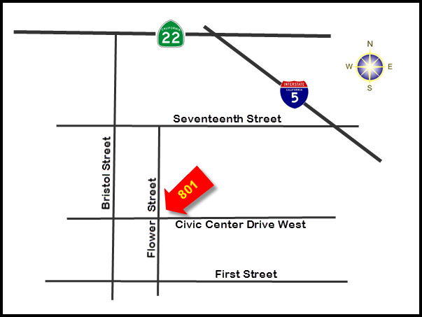
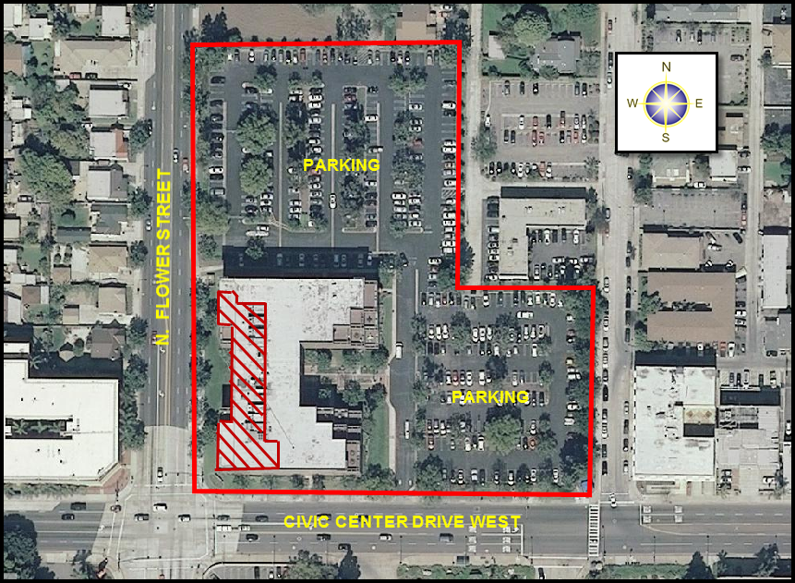
PREMISES
(Not to Scale)
801 Civic Center Drive West
Santa Ana, CA 92701

OCPW/ALS/DA-11-002
District Attorney | Prepared By: John Beck
801 Civic Center Drive West  Suite 400 | Checked By:  Antoine Williams
Santa Ana, CA 92701 | Date:  6/29/2011

REVISED EXHIBIT B (2 of 2)

SUITE 410 (Original Premises)
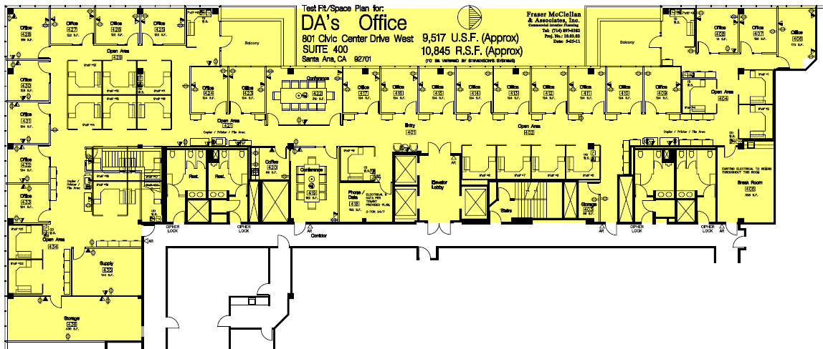

SUITE 300 (Added Full Floor)
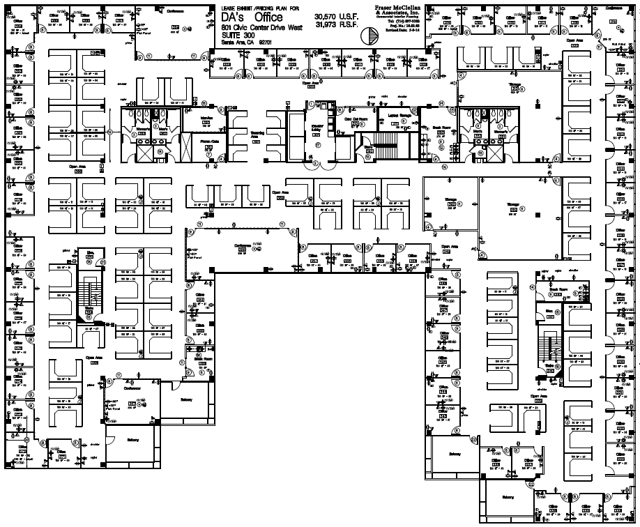

EXHIBIT C

TENANT IMPROVEMENT
PERFORMANCE SPECIFICATIONS (10.3 S)

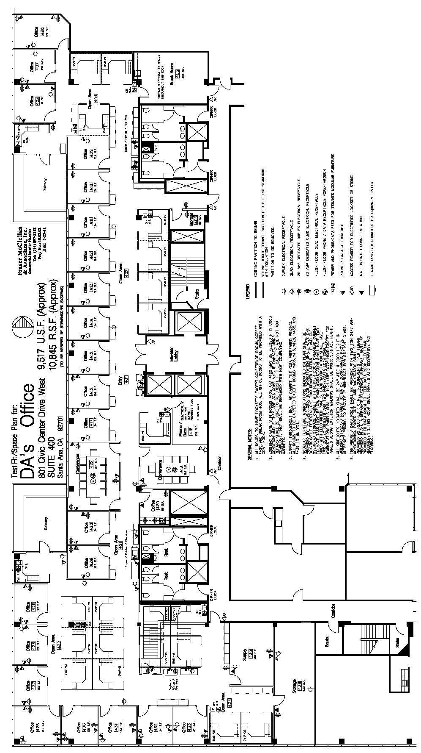

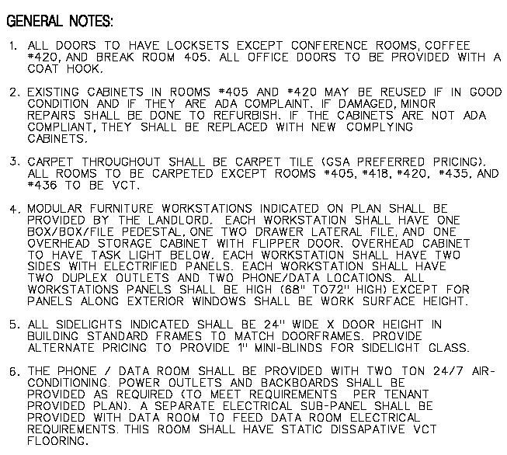

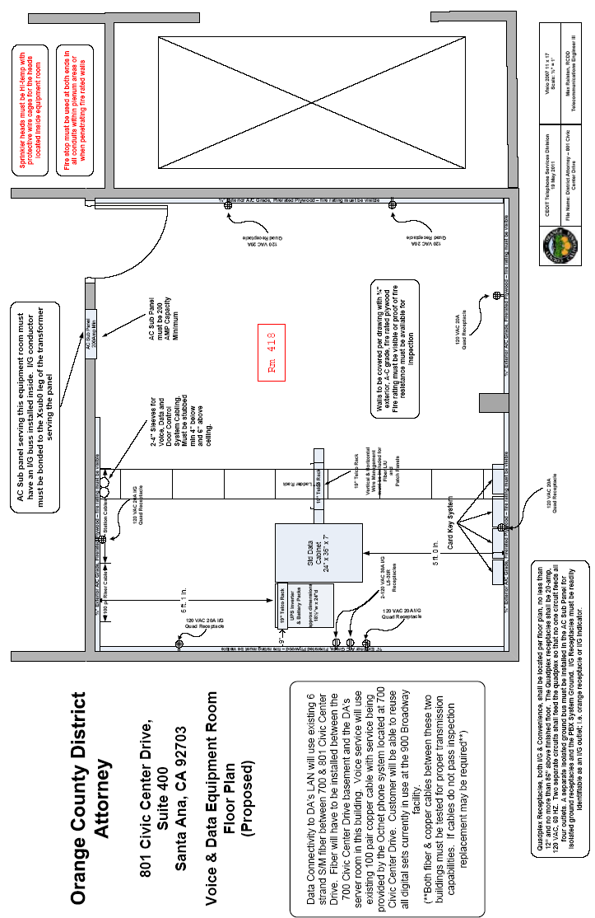
TENANT IMPROVEMENT
PERFORMANCE SPECIFICATIONS (10.3 S)

INTRODUCTION

“COUNTY” for this Exhibit “C” shall mean the District Attorney.

DIVISION 1 - GENERAL REQUIREMENTS

- All Work shall be done in accordance with these Performance Specifications. LESSOR’s architect will provide for required “acceptance” signatures from COUNTY and its Telecommunications and Data Services (where applicable).

- These Performance Specifications define minimum acceptable standards. They are not to be construed as limiting the items requiring maintenance or repair, but shall include any additional remedy necessary to repair or make safe, any unsatisfactory condition.

All Work shall be done in a neat and workmanlike manner.

- All building codes, “The Americans with Disabilities Act” (ADA), and local authorities’ requirements applicable to this facility shall be met. In case of conflict(s), codes and plans shall take precedence over these general specifications.

- COUNTY must review and sign for the acceptance of Space Plan(s) and furniture layout plan(s) prior to the commencement of

LESSOR shall provide COUNTY with one reduced set (11” X 17”) of plans for final acceptance signatures.

- Provide furniture plan(s) to COUNTY. The furniture shown on plan(s) is not a part of this contracted Work, and modular partitions are not deemed to be “furniture” for purposes of this clause.

Changes to the accepted Space Plan(s) and Specifications shall be made only upon written approval by COUNTY.

COUNTY shall be notified immediately by LESSOR/Contractor should any discrepancy or other question(s) arise pertaining to the working drawings that cause deviation(s) in any way from the accepted space plan(s) or specifications.

- LESSOR shall be solely responsible for any resultant costs of field modifications/changes from the accepted space plan(s) due to unforeseen building conditions and/or code requirements.

- All materials shall be at a minimum commercial-grade quality. Finishes and colors shall be selected by COUNTY prior to commencement of Work.

- LESSOR/Contractor shall verify all dimensions and conditions at the site, and LESSOR/ Contractor shall submit in writing said verified dimensions and conditions to COUNTY before starting Work. Noted dimensions take precedence over scale.

- Provide & Install, (P&I), security as required by COUNTY, city building ordinances where applicable, and COUNTY’s safety officer.

- LESSOR’s architect shall generate a punch list and furnish COUNTY with two copies of said punch list at the time of substantial completion inspection.

- COUNTY recognizes that LESSOR/Contractor will be using existing improvements and materials whenever possible. However, COUNTY shall the right of final selection of colors, finishes and styles.

- All materials whether new, used, relocated or existing shall be free of defects and shall look like new in appearance.

- These space plan(s) were not prepared for the intent of obtaining building permits. Any additional plans or details necessary to obtain the required permits shall be the responsibility of the LESSOR.

- Computer Aided Drafting; All specific requirements for this project shall be detailed to COUNTY’s, COUNTY satisfaction.

- Submission of all CAD data files shall be in one of the following software formats:
- Micro Station DGN format; Microsoft Windows based system
- AutoCAD DXF format: Microsoft Windows based system
- Other (Generic DXF format: Microsoft Windows based system)

Submission of all CAD data files must be in one of the following media formats:
- Compact disc ROM (read only memory)

If the submitted generic DXF format CAD data files cannot be translated into MisroStation, AutoCad DXF format will be required.

No other formats accepted unless approved by COUNTY Department. COUNTY reserves the right to reject CAD files delivered in any other formats not specified above, or not approved.

DIVISION 2 - SITEWORK

- LESSOR, at LESSOR’s expense, shall provide any required work involving the removal or abatement of any asbestos containing materials and comply with all applicable regulations; including, but not limited to, those promulgated by the Environmental Protection Agency, the Occupational Safety and Health Administration, and the California Code of Regulations.

- Provide any wall and floor saw-cutting and/or core-drilling needed to complete the installations of all equipment, fixtures, and utilities shown on space plan(s).

- Provide freshly slurried parking lot and stall striping for number of spaces agreed to in Lease.

- P&I stenciling on curbs and pavement as specified by COUNTY.

DIVISION 3 - CONCRETE

- P&I all floor reinforcing in areas where raised flooring is supporting high concentrations of weight [i.e.: telephone room(s), file, storage rooms, etc.].

DIVISION 4 - MASONRY

NONE

DIVISION 5 - METALS

- Partition framework, except as otherwise indicated, shall be of 4” nominal stud construction.

DIVISION 6 - WOOD & PLACTICS

- P&I upper and lower cabinets. All built-in cabinets shall have a laminated plastic top, edge and 4” splash. Exposed corners shall be rounded with a minimum of 1” to a maximum of 1½” radius.

P&I 4’x 8’x ¾” plywood backboard(s) on all four walls in the COUNTY’s telephone room. Backboard(s) shall be treated with a fire retardant application as required by fire/building codes. The IT room will match the requirements per the layout by CEOIT Telephone Services Division, Dated 19 May 2011.

DIVISION 7 - THERMAL & MOISTURE PROTECTION

- All new full height partitions shall be sound insulated, have at least 3” fiberglass insulation and a Sound Transmission Class (STC) rating of 49 minimum.

DIVISION 8 - DOORS & WINDOWS

Door frames shall be of commercial grade wood or metal, acceptable for heavy-duty use. Solid-core wood doors shall be installed throughout.

- P&I keyed entry doors permitting free access during business hours and entry by key only on non-business hours. Keyed bolt lock(s) are not acceptable on the interior side of the entry door. The key system (master and sub-master set-up) and number of keys will be determined by COUNTY and provided by the LESSOR.

Doors shall be equipped with a standard passage latch unless noted otherwise and shall have a maximum finished floor clearance of 3/16.”

- P&I door stops for all doors.

- Coat hooks shall be installed on the inside of all private office doors at 65-inches from the base of the door, unless otherwise specified by the District Attorney.

- P&I vision panels on all hallway doors, Interview rooms, conference rooms, store rooms, lunch rooms and any other doors to high traffic areas.

- P&I kick plates on designated doors.

- P&I automatic closures on doors as indicated as required by applicable codes.

- Compliance with ADA; Contractor shall furnish all labor, material, permits and drawings to convert existing manual entry doors to ADA Automatic Entrances in compliance with Federal ADA requirements and local codes. The LESSOR may comply by either installing a fully automatic door with seeing eye/motion opening/closing or by installing electric automatic door operators as requested by the County. In the event of the latter the conversion shall include: Installation of electric automatic door operators, electrical wiring and circuitry, electronic control, direct wire wall switches, full width header, safety signage on doors, and any element necessary for the 100% completion in accordance with ADA Accessibility Guidelines, and COUNTY specifications.

- Existing windows shall be cleaned and restored to first-class working condition and color matched to new construction. Caulk and weather-strip as necessary in order to obtain full weatherproofing. Replace window tinting as requested by COUNTY.

DIVISION 9 - FINISHES

- Partitions, except as otherwise indicated, shall have a minimum ⅝” gypsum board on each side. Joints shall be taped or joined with acceptable mechanical joints to provide a continuous surface, suitable for a high-grade durable finish. All newly constructed wall intersections in heavy traffic areas shall receive a “Bullnose” detail treatment (corner guards are acceptable).

- All gypsum board partitions shall be treated with one sealer coat, then painted with one undercoat and one finish coat of Dunn-Edwards® semi-gloss latex paint or accepted equivalent.

- Restroom wainscot(s) shall be 54” high ceramic tile, or other acceptable material(s) approved by The District Attorney.

- The ceiling height shall be a minimum of 8’- 6” to 9’- 0” throughout (except restrooms), or other acceptable wall height(s) approved by COUNTY.

- Acoustic tile to be installed for all ceilings and soffits.

- New or reconditioned ceilings shall be acoustical material faced.

- P&I new flooring finish materials that meet or exceed the requirements of this section.

- All areas are to be carpeted unless noted otherwise.

- Carpet shall be direct glue down and shall meet the following specifications:

- Specifications for Broadloom Carpet:
  - 100% Antron 6,6 continuous filament nylon, 100% yarn dyed, 100% solution dyed or a combination of yarn and solution dyed with permanent static control and soil and bleach resistant technology applied by mill.
  - Minimum yarn weight 26 ounces, minimum density 6,000.
  - Unitary back with 15-year warranty against edge ravel, zippering and delamination.
  - To be installed using manufacture’s recommended adhesives.
  - Must meet NSF-140 specification for a “Gold” level of compliance at a minimum.
  - Construction to be tufted or woven, level or multi-level loop pile with maximum pile height variation of 1/32 inch.

- Specifications for Modular Carpet Tile:
  - 100% Antron 6,6 continuous filament nylon, 100% yarn dyed, 100% solution dyed or a combination of yarn and solution dyed with permanent static control and soil and bleach resistant technology applied by mill.
  - Minimum yarn weight 20 ounces, minimum density 6,000.
  - Modular tile size shall be min. 18” squares up to a max. 24” squares.
  - Closed cell non-aqueous polymer backing with lifetime warranty against wick back of stains, edge ravel, zippering and delamination.
  - To be installed using manufacture’s recommended adhesives.
  - Must meet NSF-140 specification for a “Gold” level of compliance at a minimum.
  - Construction to be tufted or woven, level or multi-level loop pile with maximum pile height variation of 1/32 inch.

- Unless otherwise specified or required by code, vinyl composition tile (VCT) shall be a minimum of 3/32” thick with color and pattern completely through tile thickness.

- P&I new 4-inch high wallbase throughout.

- Restroom floors shall be ceramic tile, or other material(s) approved by COUNTY.

- New or existing doors and frames shall be painted or refinished with undercoat, split-coat, and finish coat of semi-gloss enamel. Doors and frames with wood grains shall be stained with two coats of lacquer.

DIVISION 10 - SPECIALTIES

- P&I signage to consist of, but not limited to: exterior sign(s), directory sign(s), suite entry door sign(s), room and cubicle numbers, department title(s), maximum occupancy for high density rooms, no smoking signs, emergency evacuation plan(s) in lobbies, all conference rooms and training rooms, and all required exit signs with directional arrows, parking lot signs and other signs as required by COUNTY, and local codes and ordinances.

All signs to be done to COUNTY and ADA standards, including but not limited to, Braille requirements, etc.

- P&I ABC type fire extinguishers with semi-recessed plastic face cabinets as required by codes and COUNTY’s safety officer; and appropriate type fire extinguishers in all computer room(s) and/or telephone switch room(s). Install L projecting wall signs identifying location of extinguishers.

- Restrooms shall be provided with required accessories including, but not limited to: mirrors w/shelf, soap dispensers, feminine napkin-recessed vendors, and disposal receptacle for the napkins in each and every (woman’s) stall, semi-recessed paper towel dispensers with waste receptacles, toilet seat cover dispensers, a clothes hook in each toilet compartment and other fixtures as required by COUNTY.

- Toilet partitions shall be 70” in height.

- Cabinets with sinks shall be provided with a paper towel dispenser(s) and a recessed waste receptacle(s). In addition, cabinets in employees’ lounge(s) shall include liquid soap dispenser(s).

- Baby changing-tables shall be provided in all public restrooms.

DIVISION 11 - EQUIPMENT

NONE

DIVISION 12 – FURNISHINGS

P&I new mini and/or vertical blinds on all interior and exterior glazing (including door glazing); blinds to be Levelor® or equal quality, with final selection of type of blinds made by COUNTY.

Provide pre-cast concrete trash receptacles and cigarette urns placed outside main building entrances.

DIVISION 13 - SPECIAL CONSTRUCTION

NONE

DIVISION 14 - CONVEYING SYSTEMS

NONE

DIVISION 15 - MECHANICAL

- Piping, whether conducting liquids or venting, shall be concealed within the walls. No exposed piping is permitted. Only water conserving plumbing fixtures shall be acceptable.

- Provide floor drains for overflows in all restrooms.

- P&I drinking fountain(s) in accordance with the Uniform Plumbing Code (UPC) and the “Americans with Disabilities Act” (ADA) requirements as applicable; and in addition, as may be required by COUNTY. Drinking fountain(s) shall have lines with replaceable filters.

- Cabinets with sinks shall be provided with hot and cold water. In addition, cabinets in employees’ lounge(s) shall include a sink with a 3/4 hp commercial grade food waste disposer.

- Heating and air conditioning equipment shall have the capability of maintaining all occupied indoor areas at the room temperatures shown when outdoor temperatures are as follows:

Outdoors Maintain Indoors

Summer - 95 º dry bulb 78 º dry bulb at maximum range of 40% to 60% relative humidity.

Winter - 35 º dry bulb 68 º dry bulb

- All HVAC controls pertinent to the Premises are to be located within the Premises.

- All HVAC thermostats shall be concealed by a clear plastic tamperproof lock box.

- The ventilation system shall supply a minimum of 20 cubic feet/minute of outside air per occupant. The HVAC system shall be capable of keeping the indoor concentration of carbon dioxide below 1,000 parts per million. There shall be an averaged air velocity of 20 feet per minute through the work space to sufficiently distribute the air. The HVAC supplies and returns shall move such volumes of both recirculated and outside volumes of air so that the mixing rate will be at least 10 air changes per hour.

- All systems in operation shall not exceed noise levels of NC-35 within any portion of the Premises.

- Restrooms are to be vented to the outside. Mechanical exhaust ventilation to the outside must be provided for restrooms that are within the office building and kitchen/break areas supplied with cooking facilities (other than microwave ovens).

- Ductwork shall be concealed above the ceiling.

- P&I “sound boots” for all HVAC return air grills at plenum ceilings in offices and conference rooms only; open areas and other rooms shall have standard return air grills.

- Each room shall have at least one supply and one return register.

- In telephone/IT equipment room, P&I ceiling exhaust fan one (1) A/C unit with thermostatic control set to activate at 75º F for 24-hour operation. Air conditioning for the Premises shall include vent and return within telephone equipment room to maintain room temperature at 75º F.

- A color-coded “HVAC Zoning Plan” indicating the areas served by each thermostat shall be provided to COUNTY upon project completion.

- On any newly installed or modified HVAC system, an air balance check shall be performed, any necessary adjustments shall be made, and a report shall be furnished to the District Attorney.

DIVISION 16 - ELECTRICAL

- All telephone and other communication equipment shown on the space plan(s) shall be provided in accordance with the information furnished by COUNTY’s Telecommunications who, in conjunction with the District Attorney, will both review and accept the space plan(s).

- Illuminated EXIT signs with 6” high minimum letters shall be installed in hallways, conference rooms, and any other high-density occupancy rooms.

- Lighting shall be recessed into the ceiling and meet the lighting levels required in this section.

- P&I fluorescent lighting at all interior spaces that meet code and provide the following minimum lighting intensities at desk level:

MINIMUM FOOT-CANDLES:
General Offices/Utility Rooms 60
Public Areas 30
General Corridors 20
Other interior areas I.E.S. Recommended Levels
Parking Lot 1

- All lighting controls pertinent to the Premises shall be located within the Premises.

- All electrical panels exclusively serving the Premises shall have an individual electrical expansion capacity of no less than 30% and have panel -mounted-mode ACCUVAR surge suppression systems on the electrical panels serving outlets inside each floor space and telephone closets.

- All communication jacks shall have a receptacle box with 3/4” diameter conduit stubbed out into accessible ceiling space and a pull string provided. No exposed conduit is permitted. Provide solid cover plates for jacks that are not in current use. COUNTY’s Telecommunications and COUNTY must both be notified in writing by LESSOR/Contractor as to whether or not the Premises will have an HVAC return air plenum ceiling. All existing wiring must meet current applicable fire/building codes or must be removed and/or replaced by LESSOR/ Contractor.

- For single tenant or multi-tenant buildings without telephone company provided Intra-building Network Cable (INC): P&I 4” EMT diameter conduit from the telephone company’s designated Minimum Point of Entry (MPOE) to COUNTY’s telephone backboard(s) and provide pull string as necessary.

- For multi-tenant buildings with telephone company provided Intra-building Network Cable (INC): provide ____ cable pairs for COUNTY, tagged at each distribution point in the building, for COUNTY’s exclusive use. LESSOR shall maintain a contract with telephone company for repair and maintenance of INC. LESSOR/Contractor shall P&I ____-____ diameter conduit from INC floor terminal room to COUNTY’s backboard(s) and P&I string as necessary.

- Center ____-____ diameter sleeve(s) above each telephone backboard. Terminate 1’ above and below ceiling line in accessible plenum space. P&I 4” EMT diameter sleeves at all fire corridors.

- At the COUNTY’s telephone backboards: P&I a dedicated 110 VOLT 20 AMP quadruplex receptacle at each backboard location and P&I an isolated ground from main electrical room. Use a standard 6 GA equipment room grounding conductor. This will match requirements provided by CEO/IT Telephone Services Division, dated May 19, 2011.

- For buildings without fire alarm systems: P&I alarm system and smoke detectors to current applicable codes and standards.

- For buildings with fire alarm systems, provide test results to COUNTY showing the system meets current code(s) and standard operational guidelines.

- Compliance with ADA; In preparing the plans, the LESSOR’s architect shall assure that the plans comply with all requirements of the “Americans with Disabilities Act (ADA)”, including audible and visual smoke and fire alarm devices applicable to a public services office.

- All electrical outlets in public use areas shall have child-proof receptacles.

- Variable light control (dimmer) switches shall be installed in all conference and training rooms.

- Emergency lighting shall be provided in all hallways, stairwells, elevators, and parking structures.

- Parking lot lighting shall be controlled with light-sensor devices designed to activate whenever conditions of low levels of natural daylight exist.

- Where applicable, P&I J-boxes in the ceiling to accommodate power pole feeds for modular workstations. Coordinate with the modular vender for location and number of J-boxes.

- Each office and modular work station shall have one four-plex and one phone jack (w/pull string) on the primary wall. On the opposite wall one duplex receptacle, one orange duplex receptacle (isolated ground w/no more than four outlets per 20amp circuit), and one phone jack (w/pull string) and solid cover plate.

- Building Exterior; All areas to be securely lighted at night.
EXHIBIT D

JANITORIAL SPECIFICATIONS (10.4 S)

It is the intent of this Exhibit to provide general guidelines for minimum janitorial service. Any absence of a specific janitorial service from this Exhibit does not relieve LESSOR of the obligation to provide such service should it become necessary.

“Five-day-per-week” janitorial service as required in Clause 16 (REPAIR, MAINTENANCE AND JANITORIAL SERVICE), of this Lease, shall be inclusive of, but not limited to, the services as detailed below:

OFFICE AREAS

NIGHTLY: Monday through Friday, inclusive. (Holidays of the County of Orange excepted).

- Empty and clean all waste receptacles, supply liners for waste receptacles, replace light bulbs and fluorescent tubes, remove waste materials from the Premises and wash receptacles as necessary;
- Mop all uncarpeted areas;
- Vacuum all carpeted areas in offices, lobby and corridors;
- Hand-dust all office furniture, fixtures and all other horizontal surfaces;
- Remove all finger marks and smudges from doors, door frames, around light switches, private entry glass and partitions;
- Wash, clean and polish water fountain;
- Spot clean carpet as necessary;
- Clean sink and wipe down tables and counter areas in all break areas and coffee bars.

WEEKLY:

- Wipe clean and polish all metal and bright work;
- Mop and polish all resilient flooring;
- Dust in place all picture frames, charts, graphs, and similar wall hangings;
- Spot-clean all wall marks;
- Sweep all sidewalks and ramps.

MONTHLY:

- Dust all mini-blinds within the Premises;
- Vacuum all HVAC vents, high moldings and other areas not reached by nightly or weekly cleaning;
- Scrub and wax uncarpeted floors.

SEMI-ANNUALLY:

- Clean ceiling light diffusers;
- Clean carpet in high traffic areas (corridors, near lunchroom,...etc) and other areas as needed;
- Clean interior walls, as needed;
- Strip and wax uncarpeted floors.

ANNUALLY:

- Clean carpet throughout Premises.

RESTROOMS

NIGHTLY:

- Clean and damp-mop floors;
- Wash all mirrors, bright work and enameled surfaces;
- Wash and sanitize all basins, bowls, urinals, and toilet seats;
- Dust, clean, and wash where necessary, all partitions, tile walls, dispensers, and receptacles;
- Empty and sanitize all receptacles and sanitary napkin disposals;
- Provide materials and fill all toilet tissue, towel, seat cover, sanitary napkin, and soap dispensers.

MONTHLY:

- Machine strip restroom floors and apply finish/sealer where applicable;
- Wash all partitions, tile walls, and enamel surfaces;
- Vacuum all louvers, vents, and dust light fixtures.

MISCELLANEOUS SERVICES

- Maintain building lobby, corridors, and other public areas in a clean condition;
- Parking lot is to be cleaned on a monthly basis;
- All interior and exterior windows of the building are to be cleaned quarterly.

SUSTAINABILITY

COUNTY seeks to promote sustainability principles into its business operation by promoting responsible use of materials and equipment and encourages LESSOR to adopt a similar business philosophy in maintaining the Premises. Some possible sustainability concepts and practices LESSOR may promote in its sustainability plan include, but is not limited to the following:

- Utilizing green suppliers/vendors
- Recycling and resource recovery
- Identify and utilize energy efficient products
- Cost and value appropriately sustainability options

