RESOLUTION OF THE BOARD OF SUPERVISORS OF ORANGE COUNTY, CALIFORNIA ACTING IN ITS CAPACITY AS THE LEGISLATIVE BODY OF COMMUNITY FACILITIES DISTRICT NO. 2021-1 OF THE COUNTY OF ORANGE (RIENDA) CERTIFYING ELECTION RESULTS AND AUTHORIZING FILING OF VALIDATION ACTION

December 7, 2021

WHEREAS, the Board of Supervisors of the County of Orange (the “Board of Supervisors”) called and duly held an election on November 23, 2021 within the boundaries of Community Facilities District No. 2021-1 of the County of Orange (Rienda) (“Community Facilities District No. 2021-1” or the “District”) pursuant to Resolution Nos. 21-135 and 21-136 for the purpose of presenting to the qualified electors within the District Propositions A, B and C, attached hereto as Exhibit A; and

WHEREAS, there has been presented to this Board of Supervisors a certificate of the Registrar of Voters canvassing the results of the election, a copy of which is attached hereto as Exhibit B;

NOW, THEREFORE, the Board of Supervisors of the County of Orange acting in its capacity as the legislative body of Community Facilities District No. 2021-1 of the County of Orange (Rienda) DOES HEREBY RESOLVE, ORDER AND DETERMINE AS FOLLOWS:

SECTION 1. Each of the above recitals is true and correct and is adopted by the legislative body of the District.

SECTION 2. Propositions A, B and C presented to the qualified electors of the District on November 23, 2021 were approved by more than two-thirds of the votes cast at said election and Propositions A, B and C each has carried. The Board of Supervisors, acting as the legislative body of the District, is hereby authorized to levy on the land within the District the special tax described in Proposition B for the purposes described therein and to take the necessary steps to levy the special tax authorized by Proposition B and to issue bonds in an amount not to exceed
$165,000,000 specified in Proposition A.

SECTION 3. The Clerk of the Board is hereby directed to record in the Office of the County Recorder within fifteen days of the date hereof a notice of special tax lien with respect to the District which Bond Counsel to the District shall prepare in the form required by Streets and Highways Code Section 3114.5.

SECTION 4. Each of the County Executive Officer, the Chief Financial Officer and the Public Finance Director of the County, and their designees (each, an “Authorized Officer”), acting alone, is hereby authorized and directed to institute a proceeding under Section 860 et seq. of the Code of Civil Procedure of the State of California with respect to any and all issues arising in connection with the formation of the District, the incurrence of bonded indebtedness for the purposes described in Proposition A, and the levy of the special tax as set forth in Proposition B which properly may be brought before the Court in such a proceeding, including, but not limited

to, the validity of any and all actions taken or to be taken with respect to the election, the issuance of bonded indebtedness and the financing of public facilities as approved by the electors. The Authorized Officers are, and each of them acting alone is, hereby authorized and directed to file such papers, affidavits and documents and take all such other actions as may be necessary or appropriate for purposes of successfully maintaining such action.

SECTION 5. This Resolution shall be effective upon its adoption.

EXHIBIT A

COMMUNITY FACILITIES DISTRICT NO. 2021-1 OF THE COUNTY OF ORANGE (RIENDA)

SPECIAL TAX AND SPECIAL BOND ELECTION

, 2021

You are entitled to cast _ votes.

To vote, stamp a cross (+) in the voting square after the word “YES” or after the word “NO”. All marks otherwise made are forbidden. All distinguishing marks are forbidden and make the ballot void.

If you wrongly mark, tear, or deface this ballot, return it to the Registrar of Voters and obtain another.

PROPOSITION A: Shall Community Facilities District No. 2021-1 of the County of Orange (Rienda) (the “District”) incur an indebtedness and issue bonds in the maximum principal amount of $165,000,000, with interest at a rate not to exceed eight percent (8%) per annum, to finance the Facilities and the Incidental Expenses described in Resolution No. - of the Board of Supervisors of the County of Orange establishing the District?  PROPOSITION B: Shall a special tax with a rate and method of apportionment as provided in Resolution No.  - of the Board of Supervisors of the County of Orange establishing the District be levied to pay for the Facilities, Incidental Expenses and other purposes described in Resolution No. - , including the payment of the principal of and interest on bonds issued to finance the Facilities and Incidental Expenses? | YES  NO  YES  NO
PROPOSITION C: For each year commencing with Fiscal Year 2022-2023, shall the appropriations limit, as defined by subdivision (h) of Section 8 of Article XIII B of the California Constitution, for Community Facilities District No. 2021-1 be an amount equal to $16,500,000? | YES  NO

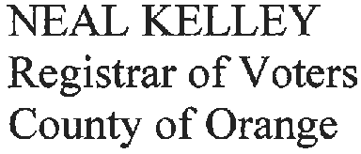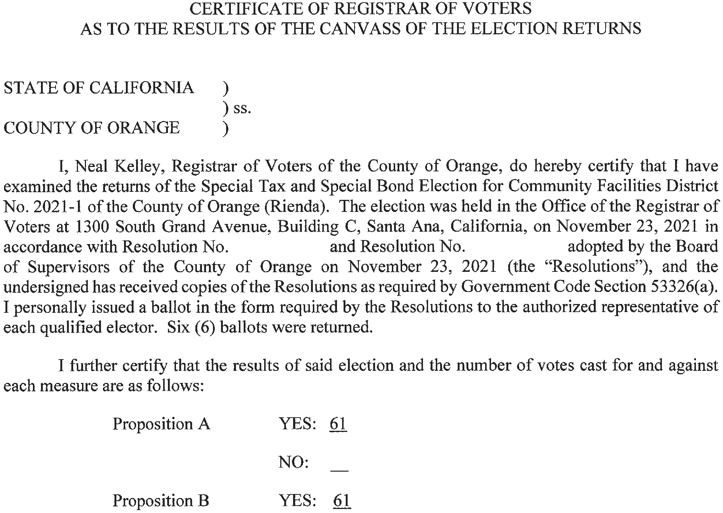

Page 4 of 4

